An Informal Eucharist Service

The Liturgy of the Word

The president says: Grace, mercy and peace be with you.

All And also with you. Faithful one whose word is life
Come with saving power - to free our praise
Inspire our prayer - and shape our lives
For the kingdom of your son, Jesus Christ our Lord. Amen.

A hymn/song is sung

Prayer of Penitence
The invitation to confession is given informally.

President … Lord, have mercy.
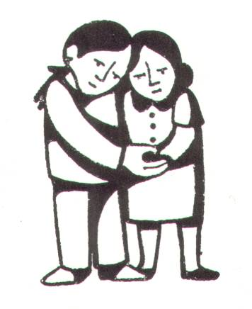
All Lord, have mercy.
President … Christ, have mercy.
All Christ, have mercy.
President … Lord, have mercy.
All Lord, have mercy.

Absolution

The Collect

The Gospel Reading

Reflection on the Gospel

Prayers of Intercession can be spoken or made in silence

Taize or similar chant or song

The Peace
President The peace of the Lord be always with you.
All And also with you

President Let us offer one another a sign of peace.
The Liturgy of the Sacrament

We may sing the receiving of the elements of bread and wine:

Blessed are you Lord God of all creation.
Thanks to your goodness this bread we offer.
Fruit of the earth, work of our hands, it will become the bread of life.

Blessed be God, blessed be God, blessed be God forever, Amen. (x2)

Blessed are you Lord God of all creation.
Thanks to your goodness this wine we offer.
Fruit of the vine, work of our hands, it will become the cup of life.

Blessed be God, blessed be God …

Blessed are you Lord God of all creation.
Thanks to your goodness ourselves we offer.
Fruit of the womb, formed by your love, we are your people for your world.

Blessed be God, blessed be God …

Eucharistic Prayer

The Lord is here.
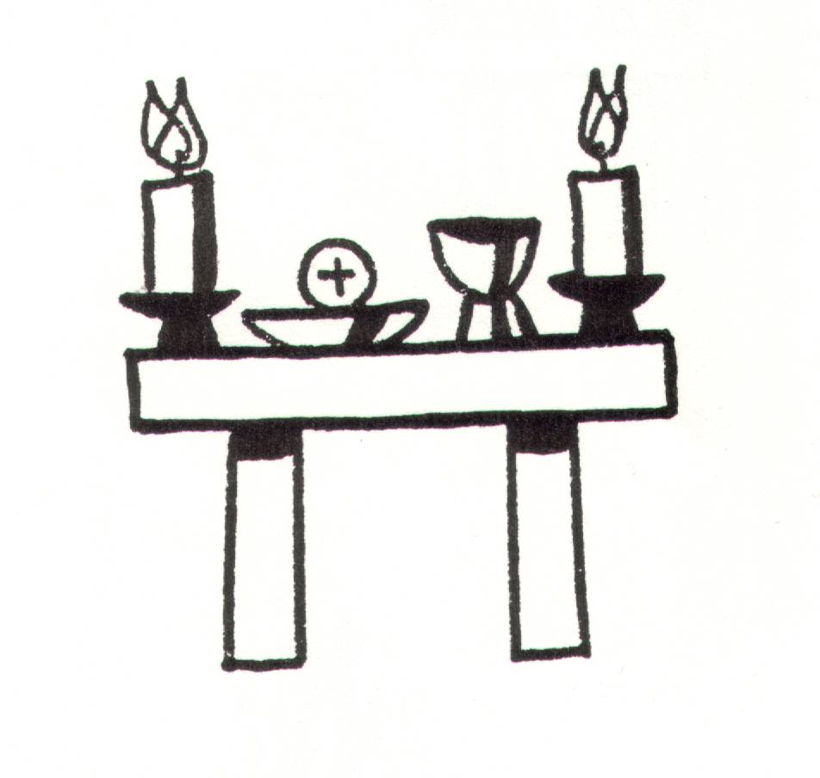
All His Spirit is with us.
Lift up your hearts.
All We lift them to the Lord.
Let us give thanks to the Lord our God.
All It is right to give thanks and praise.

The president prays a suitable Preface.

Holy, holy, holy Lord,
God of power and might,
heaven and earth are full of your glory.
Hosanna in the highest.

The president recalls the great events of the Last Supper.

Great is the mystery of faith
Christ has died:
Christ is risen:
Christ will come again.

The president continues the Eucharistic Prayer.

All Amen.
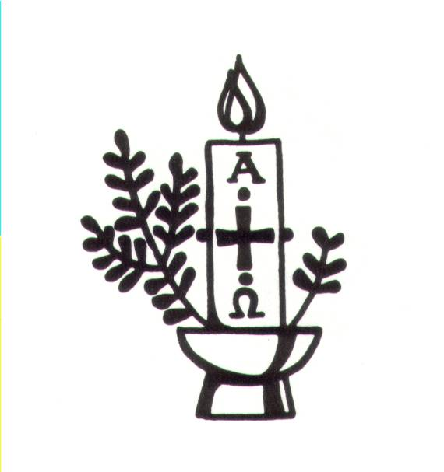

The Lord’s Prayer
The president invites the congregation to say:
All Our Father who art in heaven,
hallowed be thy name,
thy kingdom come,
thy will be done,
on earth as in heaven.
Give us this day our daily bread.
Forgive us our trespasses
as we forgive those who trespass against us.
Lead us not into temptation
but deliver us from evil.
For thine is the kingdom, the power,
and the glory, for ever and ever. Amen.

Breaking of the Bread

We break this bread
to share in the body of Christ.

All Though we are many, we are one body,
because we all share in one bread.

Draw near and receive the body of our Lord Jesus Christ which he gave for you and his blood which he shed for you and feed on him in your hearts by faith and with thanksgiving.

The congregation receives Holy Communion or a Blessing.
Silence may be kept, or music played.

Prayer after Communion

All: Almighty & Compassionate God, we thank you for feeding us
with the body and blood of your Son Jesus Christ.
Through him we offer you our souls and bodies to be a living sacrifice.
Send us out in the power of your Spirit to live and work to your praise and glory. Amen.

A hymn or song may be sung

Closing prayers
In peace we will lie down and sleep;
All For you alone, Lord, make us dwell in safety.
Abide with us, Lord Jesus
All For the night is at hand and the day is now past.
As the night watch looks for the morning,
All So do we look for you, O Christ.

The Dismissal
The president may use one of the following or another suitable blessing

The peace of God,
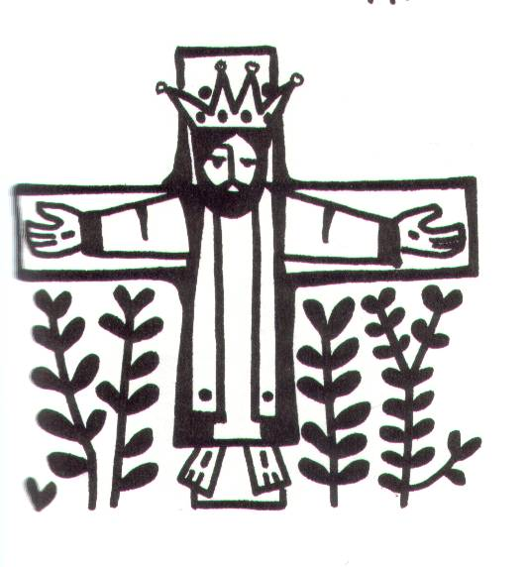
which passes all understanding,
keep your hearts and minds
in the knowledge and love of God,
and of his Son Jesus Christ our Lord;
and the blessing of God almighty,
the Father, the Son, and the Holy Spirit,
be among you and remain with you always.
All Amen.

The president says
Go in the peace of Christ to love and serve the Lord.
All In the name of Christ.

Common Worship: Services and prayers for the Church of England, material from which is included in this service, is copyright © The Archbishops’ Council 2000.

